Open XDA 3.0 official issues

General OPEN XDA errors.

1. Double ended faults do not always calculate even though the starting times of two events at the ends of the same line are within the set time. Expanded the time to 0.15 from 0.1

Does the Line ID appear in the AssetLocation table twice? Double ended fault calculation should be happening if (and only if) the line is tied to 2 Locations/Substations. You can check this in the “Substations” tab of the Line in System Center.

System Center

Most of these appear to be database schema misses. We can take a look together when you have time.

1. On the Meter Info Tab of “meters” the following error occurs.

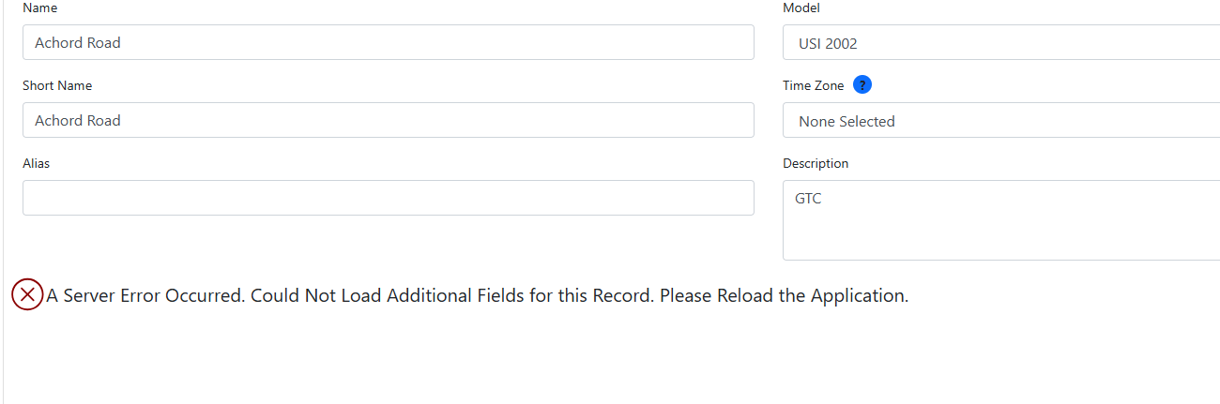

1. On the “substation info” and “additional fields” tabs of Substations the following errors occur .

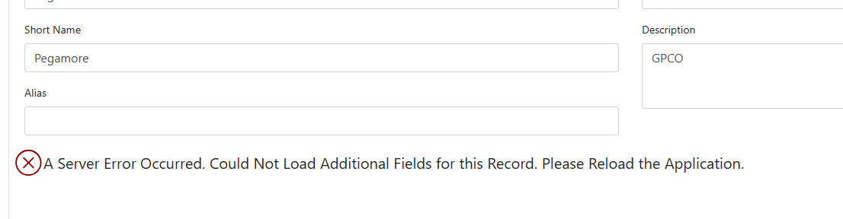

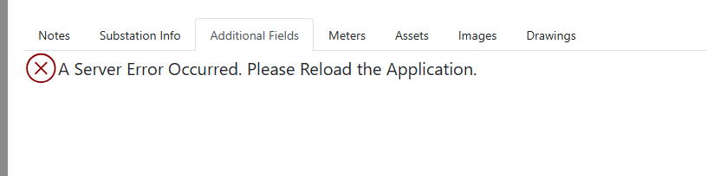

1. On the Info, Additional fields and Channels tab of Assets the Server error occurred error appears.
2. Cannot search under Line Segments
3. Pressing external Database produces the “A Server error has occurred” error
4. Under Nodes there are two instances of OpenXDA, one shows online the other swaps between loading and offline
5. New Console for either System Center or XDA accessed from “Nodes” are not displaying text.
6. Under System Settings “OpenSEE “ does not have any settings and produces a “server Error Occurred. Please Reload the Application”

PQDashboard

PQ Browser

1. When a fault is selected “Correlating events “ tab produces this error

That widget no longer exists. You can remove it from the tab in System Center under “PQ Browser Tabs” and I can help you delete it from the database.

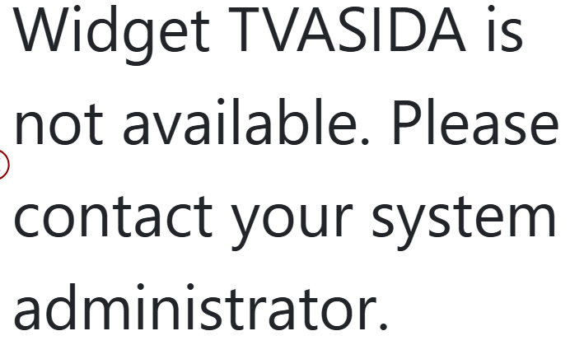

1. Asdf

OpenSee

1. “Fault button” produces this error

This is a known issue with a ticket in our system. This is supposed to load the same window as you’d find in PQ Dashboard in the “Faults” tab (the “F” and magnifying glass button shown in the screenshot below). Workarounds until we can build and deploy a fix in openSEE include finding the Fault in PQ Dashboard to view the window there or changing the root URL in the Fault Specifics popup window to your PQ Dashboard URL (should be as simple as replacing “OpenSee” with “PQDashboard” on your system I believe). Note that when I attempted to do this on my system, I had to copy the URL into a new tab/window as the browser wouldn’t let me edit the URL in the popup window.

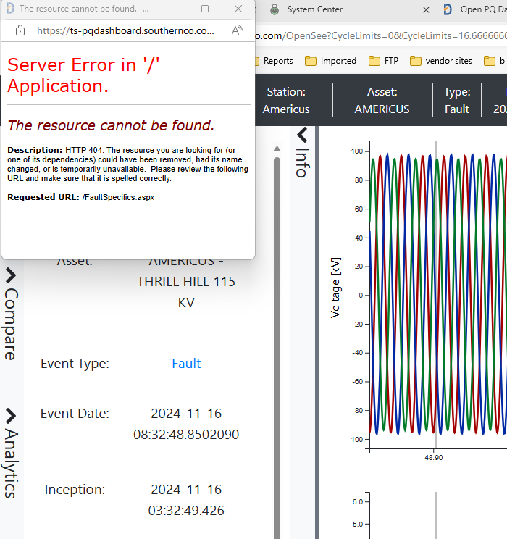

1. Edit and Manage Notes buttons produces this error.

This is fixed in the latest version of openSEE to direct the user to PQ Browser. The “Notes” widget and “Edit Event” widget there allow these options to replace dD Workbench. I’m happy to help make sure you have these widgets enabled and they are easy to find.

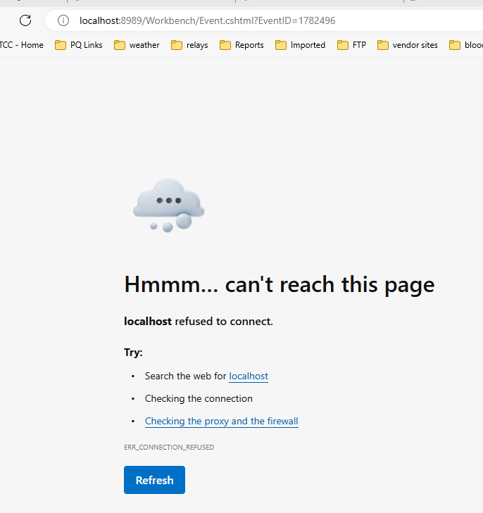

1. Under Analysis fault distance no fault distances are displayed when selected “No Data Available”

This may be a configuration issue; we’ll have to look at it together to figure out what’s happening.

1. Under Waveform Views Digitals does not display data. “No Data Available”

This is a known issue we are working on.

1. Under Waveform Views Analogs will not display (actually not sure what this is)

“Analogs” are any event channel that has a measurement type that is not Digital, Voltage, Current, or Trip Coil Current. So, this would include Power, Energy, Analog, None, or Unknown measurement types. Do you have any event channels that would fall into that classification? If so, I would bet that the issue is similar to the Digital issue, and we would appreciate an event file that has data for such a channel so we can troubleshoot and test!