March 9, 2025

Mr. Marvin Galicha
Hawaiian Electric Company
PO Box 2750
Honolulu, HI 96840

RE: Maintenance Support Services for Grid Protection Alliance, Inc., (GPA) Products

Dear Mr. Galicha:

Per your request, this is a quote for Grid Protection Alliance, Inc. (GPA) to provide Hawaiian Electric Company (HECO) hourly support consultation for the openXDA suite of tools, including the open PQ Dashboard.

Services to be Provided

GPA will provide time and materials services at a blended rate of $190/hour for up to 10 hours to support your power quality data systems resulting in a not-to-exceed cost of $2,000. All work to be performed or supervised by senior personnel. Terms of payment are net 30 days.

GPA has the technical experience and capability to quickly meet HECO’s technical needs. We look forward to this opportunity to provide support services to HECO. This offer is valid until May 31, 2025. If you have any additional questions, please do not hesitate to get in touch with me at (570) 637-7161 or clackner@GridProtectionAlliance.org.
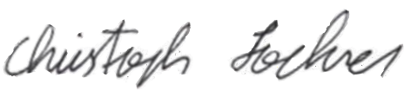
9-Mar-2025
Quote Authorization: Date:
Dr. Christoph Lackner, Operating Officer and Lead Engineer
Grid Solutions | Grid Protection Alliance, Inc.

Please sign, date, and return this quote to accept.

Quote Acceptance: Date:

