**Select VLN RMS Lower then select Edit Alarms Group**

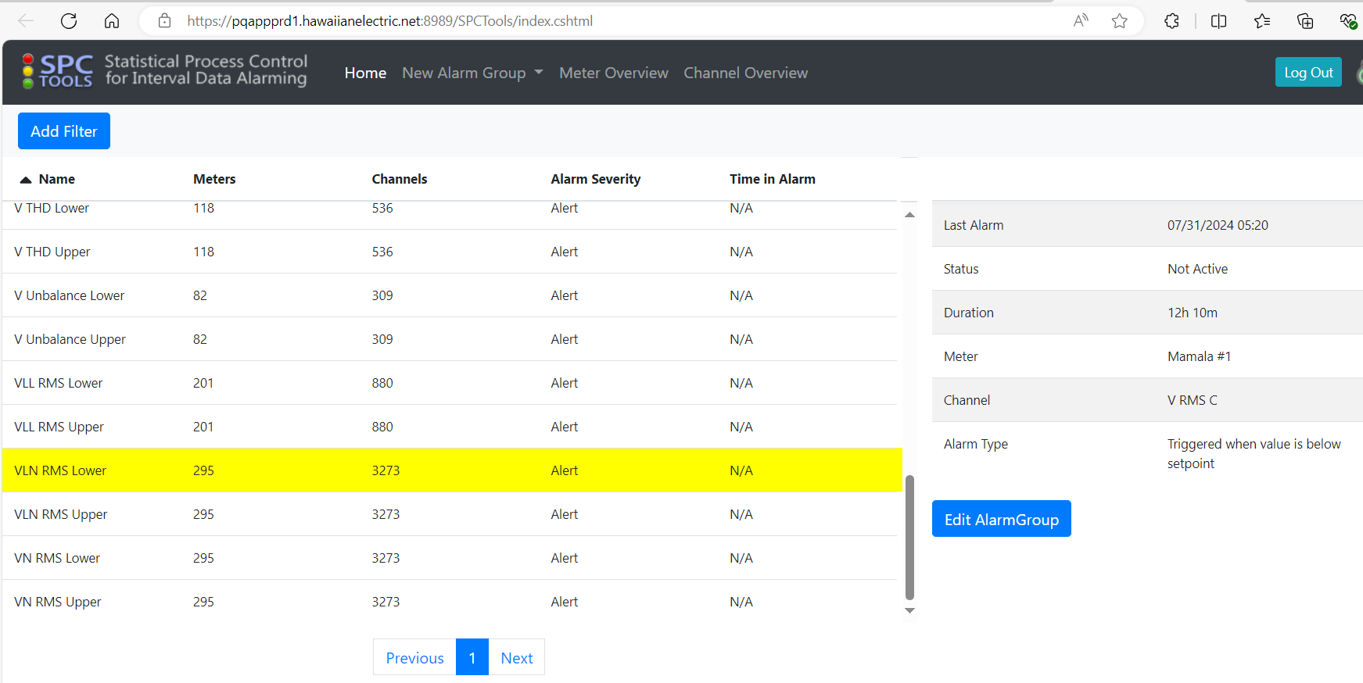

**Select for Phases All and then Continue.**

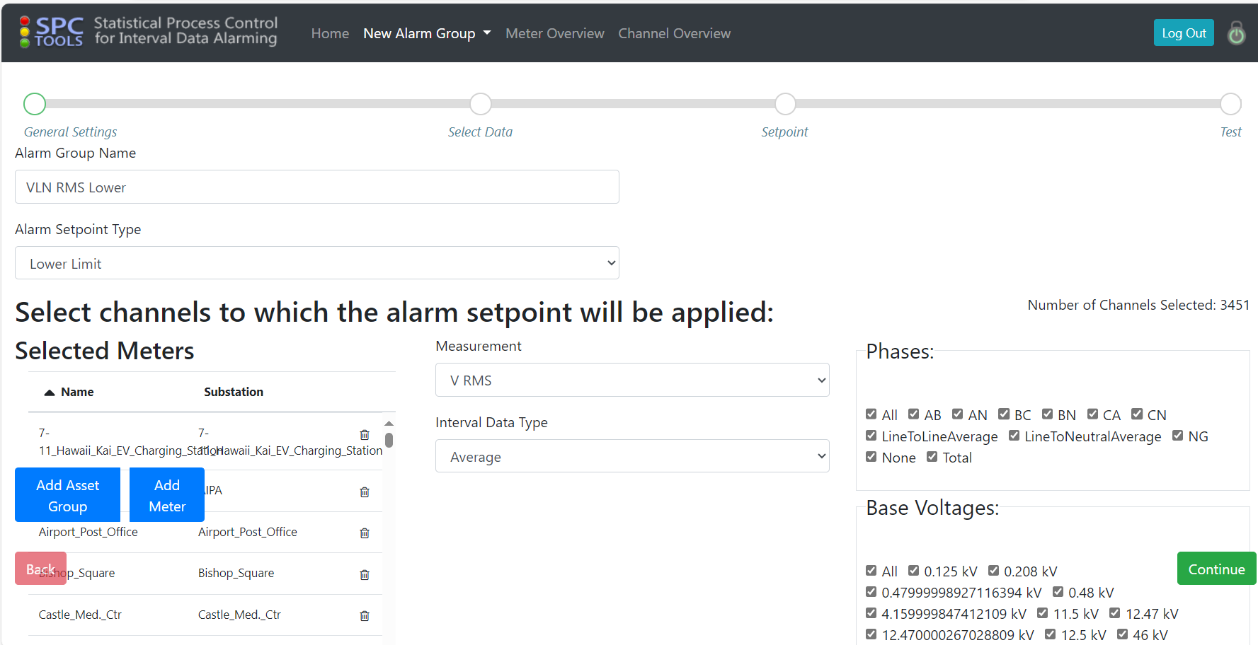

**Selected All and Continue**

Question: Regarding “Duration” what should I put here leaving customer is ok?

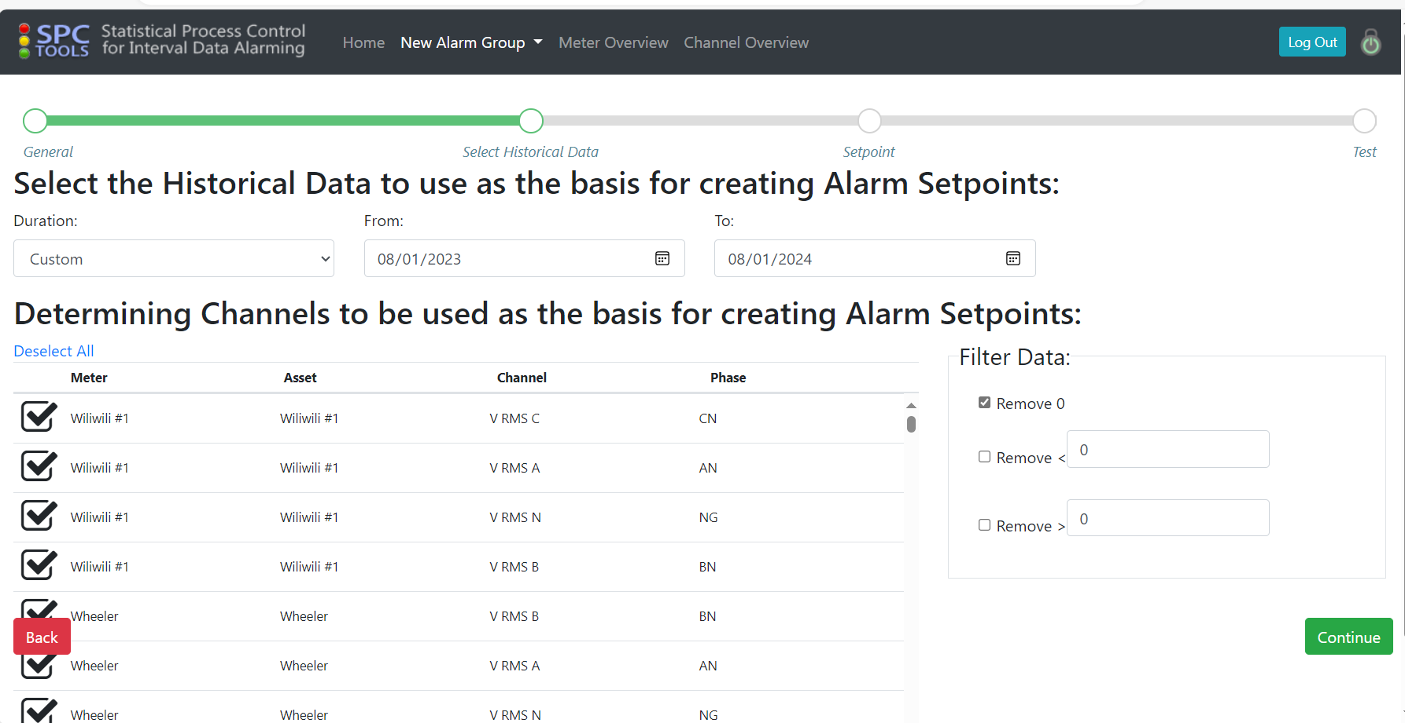

**For SetPoint input below formula and then been getting error.**

