Weekly Calendar View:

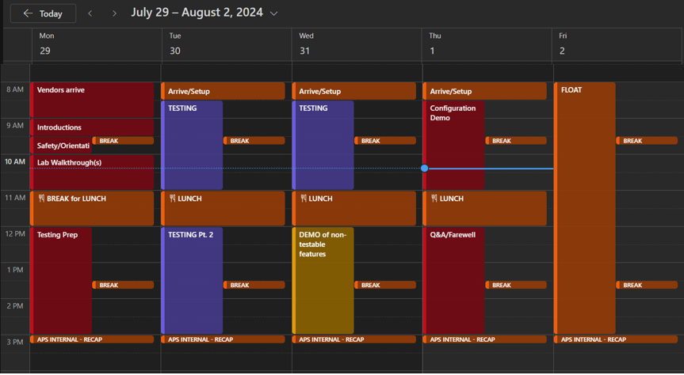

Color Code

* RED – APS in-person required
* PURPLE – SP-led lab testing, limited in-person requirement
* YELLOW – Hybrid meeting
* BROWN – Float/housekeeping tasks

Summary Agenda

* Day 1: Introductions and Vendor Lab Prep/Access Confirmation
* Day 2: Testing per test plan
* Day 3: Testing per test plan
* Day 4: Configuration walk through/Q&A
* Day 5: Floating day TBD

**Day 1:**

* 8:00AM – 9:00AM – Vendor Arrives
  + Vendors check in with APS Security and park
  + APS Point of Contact Meets with vendor and escorts them to the lab
  + Coffee/Donuts and introduction
  + APS Point of Contact ensures vendor has Network Access
* 9:00AM – 9:30AM
  + APS/Vendor introductions for team members supporting the POC
* 9:30AM – 10:00AM
  + APS point of contact provides safety presentation going over emergency procedures, fire extinguisher location, AED, evacuation plans etc.
* 10:00AM – 11:00AM
  + APS team escorts vendors in order to perform a lab walkthrough. This includes the SCADA lab to view the test set up for APS equipment and the vendor’s equipment installation.
* 11:00AM – 12:00PM
  + Break for lunch
* 12:00PM – 3:00PM
  + Vendor will ensure they have access to their equipment and prepare accordingly.
* 3:00PM – 3:30PM
  + APS Internal debrief - Review where the vendors left off/starting point for the following day

**Day 2:**

* 8:00AM – 8:30AM
  + Vendor arrival/setup
* 8:30AM – 11:00AM
  + Testing per the System Protection test plan
* 11:00AM – 12:00PM
  + Break for lunch
* 12:00PM – 3:00PM
  + Testing per the System Protection test plan
* 3:00PM – 3:30PM
  + APS Internal debrief - Review where the vendors left off/starting point for the following day

**Day 3:**

* 8:00AM – 8:30AM
  + Vendor arrival/setup
* 8:30AM – 11:00AM
  + Testing per the System Protection test plan
* 11:00AM – 12:00PM
  + Break for lunch
* 12:00PM – 3:00PM
  + Vendor will do a demo to APS for features or requirements that were not testable in the lab environment
* 3:00PM – 3:30PM
  + APS Internal debrief - Review where the vendors left off/starting point for the following day

**Day 4:**

* 8:00AM – 8:30AM
  + Vendor arrival/setup
* 8:30AM – 11:00AM
  + Vendor walks APS groups through the configuration of requested use cases
* 11:00AM – 12:00PM
  + Break for lunch
* 12:00PM – 3:00PM
  + Open Q&A between vendors and APS

**Day 5:**

* FLOAT
* Supplier to be available in case Day 5 is required.
  + Will be determined by day 3